Bryan

Nguyen

CSC-17C (47341)

**Introduction**

The project is a type of battle game where the player tries to defeat the monster. The player must use his items wisely and have some luck in order to beat the game. The monsters on each level gain increasingly higher health and attack points. Every monster has a chance to drop a potion upon death. At the end of each level, if the player successfully defeats the monster, he will also gain attack, almost like a level up. The user will continue the game by entering ‘y’ or ‘Y’ and a random number generator will decide how much damage is inflicted, based on how much attack the player and monster has. For example, if the player has 15 attack, he will do damage anywhere between 1-15 inclusive. The player will be given the option to use a potion only if he has taken damage and is not dead. Entering ‘n’ when given the choice to use a potion will keep the potion in the player’s inventory. Entering ‘n’ when given the choice to continue will simply end the game and the player must restart from the beginning when the game is begun. The player’s status progression will output at the end of each battle. Once the player wins the game or is defeated, all of the monsters’ total health will be displayed for them to see the progression.

**Summary**

The project is approximately 930 lines of code. It meets the criteria for the project because it consists of maps, sets, lists, stacks, queues, iterators, and algorithms. It took roughly a week to finish the project. There are 7 main variables, about 5 constructs and 2 objects. The idea of the project itself was not difficult to code, but it seems that it is better to learn the STL with a simpler program at first. The STL was difficult to implement because it is not like what I have seen or utilized before. The iterators were probably the most confusing part.

**Description:**

The project was coded focused mainly on objects utilizing the specified C++ STL.

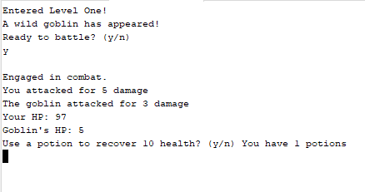



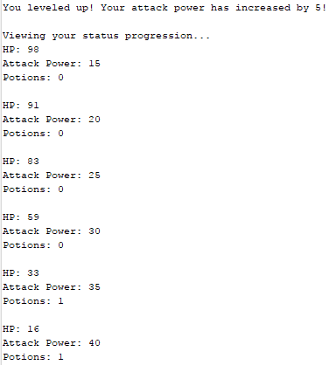

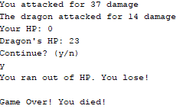

Attempted to zig zag the flow chart to make it more readable but it still does not appear to be.

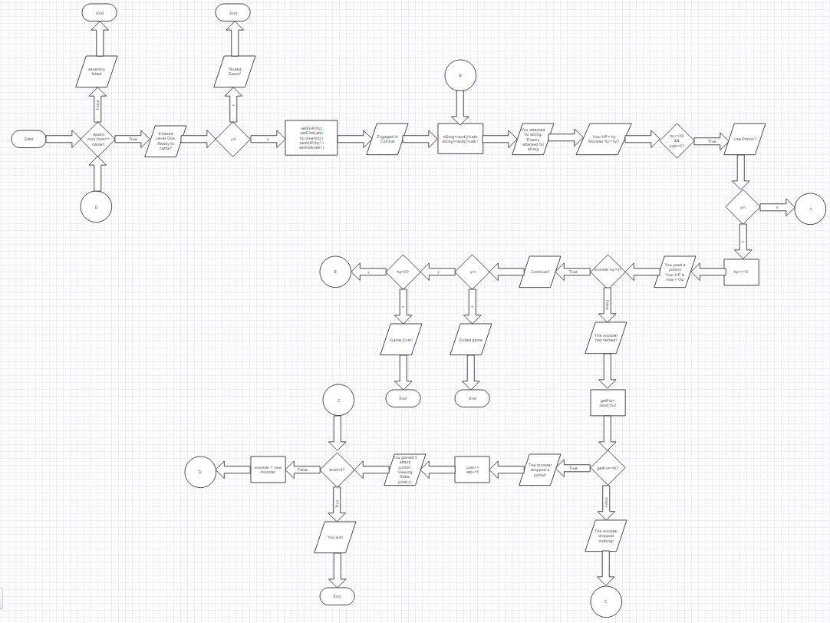

**Pseudocode**

Display Entered Game

Display ready to battle?

Get y/n

If n

Display Exited Game

If y

Set monster HP and attack

Set player HP and attack

Do

playerHP – rand()%(monster attack)+1

monsterHP – rand()%(player attack)+1

Display playerHP and monsterHP

Display use potion?

Get y/n

If y

playerHP+=10;

Display Potion Used! Hp: playerHP

If monsterHP==0

Display You defeated the monster!

Win++

If playerHP==0

Display You Lose

monster = new monster

while Win<#monsters

if win==#monsters

Display You Win!

**Classes**

|  |
| --- |
| Status |
| Lv |

**Important Variables and Constructs**

|  |  |  |
| --- | --- | --- |
| Set<int> | hp | Levels.h (27) |
| Map<const int> bool | Tier | Levels.h (28) |
| List<Lv> | L | Levels.h (29) |
| Srand |  | Main.cpp (23) |
| Int | ally, enemy, pots, aAtk, eAtk, atk1, atk2 | Status.h (20-21) |
| Queue<string> | Mon | 21 |
| Stack<string> | Monster | 22 |

**Important Concepts**

|  |  |
| --- | --- |
| **List** | **Levels.h(52-57) levels.cpp(128,232,335)….** |
| **Iterator** | **Levels.h (53) levels.cpp(131,235,338)….** |
| **Algorithm** | **Levels.h(60) main.cpp(35)** |
| **Queue** | **Levels.cpp(39-40, 143-144, 247-248)…** |
| **Stack** | **Levels.cpp(41-42, 145-146, 249-250)….** |
| **Set** | **Levels.cpp(63,166,270,373,476)….** |
| **Map** | **Levels.cpp(132,141,236,245,339,348)….** |

**Doxygen files included in order to view methods.**

I converted a piece of code from the iterator of line 53 of Levels.h in order to suit my list. I also converted the algorithm from the sgi website. I learned the C++ STL concepts from the SGI website provided, so they all should have similarities.

**Code**

**MAIN.CPP**

#include <cstdlib>

#include <ctime>

#include "levels.h"

using namespace std;

int main(int argc, char** argv) {

srand(static_cast<unsigned int>(time(0)));

Lv game;

game.l1();

game.l2();

game.l3();

game.l4();

game.l5();

game.l6();

game.l7();

game.l8();

game.prntHP();

return 0;

}

**LEVELS.H**

#ifndef LEVELS_H

#define LEVELS_H

#include <list>

#include <map>

#include <set>

#include <iterator>

#include <queue>

#include <stack>

#include <assert.h>

#include "status.h"

using namespace std;

class Lv:public Status{

private:

set< int > hp;

map<const int, bool> tier;

list <Lv> l;

public:

Lv();

void l1();

void l2();

void l3();

void l4();

void l5();

void l6();

void l7();

void l8();

void l9();

void l10();

void prntStats(){

cout << "HP: " << ally << endl;

cout << "Attack Power: " << aAtk << endl;

cout << "Potions: " << pots << endl << endl;

}

void prntEStats(){

cout << "HP: " << enemy << endl;

cout << "Attack Power: " << eAtk << endl;

cout << endl;

}

void prntL(){

for(list<Lv>::iterator it = l.begin(); it!=l.end(); it++){

Lv lv = *it;

lv.prntStats();

}

}

void prntHP(){

cout << "Defeated Monster's Total Health Points:" << endl;

copy(hp.begin(), hp.end(), ostream_iterator<int>(cout, "\n"));

}

};

#endif /* LEVELS_H */

**LEVELS.CPP**

#include <iostream>

#include <string>

#include <cstdlib>

#include "levels.h"

using namespace std;

Lv::Lv(){

tier[1]=false;

tier[2]=false;

tier[3]=false;

tier[4]=false;

tier[5]=false;

tier[6]=false;

tier[7]=false;

tier[8]=false;

mon.push("Goblin");

mon.push("Zombie");

mon.push("Sand Rat");

mon.push("Wolf");

mon.push("Tiger");

mon.push("Boar");

mon.push("Dragon");

mon.push("Baboon");

monster.push("Goblin");

monster.push("Zombie");

monster.push("Sand Rat");

monster.push("Wolf");

monster.push("Tiger");

monster.push("Boar");

monster.push("Dragon");

monster.push("Baboon");

enemy=0;

ally=0;

pots=0;

}

void Lv::l1(){

assert(mon.front() == "Goblin");

mon.pop();

assert(monster.size()==8);

monster.pop();

cout << "Entered Level One! " << endl;

char reply;

cout << "A wild goblin has appeared! " << endl;

cout << "Ready to battle? (y/n)" << endl;

cin >> reply;

reply = tolower(reply);

while((reply!='y')){

if(tolower(reply=='n')){

cout << "You have exited the game" << endl;

break;

}

cout << "Invalid response. Please enter a valid response: " << endl;

cin >> reply;

reply=tolower(reply);

}

if(reply == 'y'){

cout << endl;

setEHP(10); //Enemy HP

setAHP(100); // Ally HP

hp.insert(10);

char cont=' ';

cout << "Engaged in combat." << endl;

setAAtk(10); //Able to attack up to 10 damage

setEAtk(3); //Able to attack up to 3 damage

pots++;

do{

eDmg(); //Enemy taking damage

cout << "You attacked for " << atk1 << " damage" << endl;

aDmg(); //Ally taking damage

cout << "The goblin attacked for " << atk2 << " damage" << endl;

cout << "Your HP: " << ally << endl;

cout << "Goblin's HP: " << enemy << endl;

if(ally < 100 && pots>0){

char rsp;

cout << "Use a potion to recover 10 health? (y/n) ";

cout << "You have " << getPot() << " potions" << endl;

cin >> rsp;

rsp = tolower(rsp);

while(rsp!='y'){

if(tolower(rsp=='n'))

break;

cout << "Invalid response. Please enter a valid response: ";

cout << endl;

cin >> rsp;

cont = tolower(rsp);

}

if(rsp=='y'){

usePot();

cout << "You used a potion!" << endl;

cout << "Your HP is now " << ally << endl;

}

}

if(enemy>0){

cout << "Continue? (y/n)" << endl;

cin >> cont;

while(cont!='y'){

if(tolower(cont=='n')){

cout << "You have exited the game" << endl;

break;

}

cout << "Invalid response. Please enter a valid response: ";

cout << endl;

cin >> cont;

cont = tolower(cont);

}

}

if(ally==0){

cout << "You ran out of HP. You lose!" << endl;

break;

}

} while(cont=='y' && enemy>0);

cout << endl;

if(enemy == 0){

cout << "The goblin has fainted!" << endl;

gainPot();

cout << "You leveled up! Your attack power has ";

cout << "increased by 5!" << endl;

setAAtk(aAtk+=5);

Lv add;

add.setAHP(ally);

add.setAAtk(aAtk);

add.setPot(pots);

l.push_back(add);

cout << endl;

cout << "Viewing status progression..." << endl;

prntL();

tier[1]=true;

}

else{

cout << "Game Over! You died!" << endl;

}

}

}

void Lv::l2(){

if(tier[1]!=true)

return;

assert(mon.front() == "Zombie");

mon.pop();

assert(monster.size()==7);

monster.pop();

cout << "Entered Level Two! " << endl;

char reply;

cout << "A zombie has appeared! " << endl;

cout << "Ready to battle? (y/n)" << endl;

cin >> reply;

reply = tolower(reply);

while((reply!='y')){

if(tolower(reply=='n')){

cout << "You have exited the game" << endl;

break;

}

cout << "Invalid response. Please enter a valid response: " << endl;

cin >> reply;

reply=tolower(reply);

}

if(reply == 'y'){

cout << endl;

setEHP(15); //Enemy HP

hp.insert(15);

setAHP(getAHP()); // Ally HP

char cont=' ';

cout << "Engaged in combat." << endl;

setAAtk(getAAtk()); //Able to attack up to 10 damage

setEAtk(5); //Able to attack up to 3 damage

do{

eDmg(); //Enemy taking damage

cout << "You attacked for " << atk1 << " damage" << endl;

aDmg(); //Ally taking damage

cout << "The zombie attacked for " << atk2 << " damage" << endl;

cout << "Your HP: " << ally << endl;

cout << "Zombie's HP: " << enemy << endl;

if(ally < 100 && pots>0){

char rsp;

cout << "Use a potion to recover 10 health? (y/n) ";

cout << "You have " << getPot() << " potions" << endl;

cin >> rsp;

rsp = tolower(rsp);

while(rsp!='y'){

if(tolower(rsp=='n'))

break;

cout << "Invalid response. Please enter a valid response: ";

cout << endl;

cin >> rsp;

cont = tolower(rsp);

}

if(rsp=='y'){

usePot();

cout << "You used a potion!" << endl;

cout << "Your HP is now " << ally << endl;

}

}

if(enemy>0){

cout << "Continue? (y/n)" << endl;

cin >> cont;

while(cont!='y'){

if(tolower(cont=='n')){

cout << "You have exited the game" << endl;

break;

}

cout << "Invalid response. Please enter a valid response: ";

cout << endl;

cin >> cont;

cont = tolower(cont);

}

}

if(ally==0){

cout << "You ran out of HP. You lose!" << endl;

break;

}

} while(cont=='y' && enemy>0);

cout << endl;

if(enemy == 0){

cout << "The zombie has fainted!" << endl;

gainPot();

cout << "You leveled up! Your attack power has ";

cout << "increased by 5!" << endl;

setAAtk(aAtk+=5);

Lv add;

add.setAHP(ally);

add.setAAtk(aAtk);

add.setPot(pots);

l.push_back(add);

cout << endl;

cout << "Viewing status progression..." << endl;

prntL();

tier[2]=true;

}

else{

cout << "Game Over! You died!" << endl;

}

}

}

void Lv::l3(){

if(tier[2]!=true)

return;

assert(mon.front() == "Sand Rat");

mon.pop();

assert(monster.size()==6);

monster.pop();

cout << "Entered Level Three! " << endl;

char reply;

cout << "A wild sand rat has appeared! " << endl;

cout << "Ready to battle? (y/n)" << endl;

cin >> reply;

reply = tolower(reply);

while((reply!='y')){

if(tolower(reply=='n')){

cout << "You have exited the game" << endl;

break;

}

cout << "Invalid response. Please enter a valid response: " << endl;

cin >> reply;

reply=tolower(reply);

}

if(reply == 'y'){

cout << endl;

setEHP(25); //Enemy HP

hp.insert(25);

setAHP(getAHP()); // Ally HP

char cont=' ';

cout << "Engaged in combat." << endl;

setAAtk(getAAtk()); //Able to attack up to 10 damage

setEAtk(7); //Able to attack up to 3 damage

do{

eDmg(); //Enemy taking damage

cout << "You attacked for " << atk1 << " damage" << endl;

aDmg(); //Ally taking damage

cout << "The sand rat attacked for " << atk2 << " damage" << endl;

cout << "Your HP: " << ally << endl;

cout << "Sand Rat's HP: " << enemy << endl;

if(ally < 100 && pots>0){

char rsp;

cout << "Use a potion to recover 10 health? (y/n) ";

cout << "You have " << getPot() << " potions" << endl;

cin >> rsp;

rsp = tolower(rsp);

while(rsp!='y'){

if(tolower(rsp=='n'))

break;

cout << "Invalid response. Please enter a valid response: ";

cout << endl;

cin >> rsp;

cont = tolower(rsp);

}

if(rsp=='y'){

usePot();

cout << "You used a potion!" << endl;

cout << "Your HP is now " << ally << endl;

}

}

if(enemy>0){

cout << "Continue? (y/n)" << endl;

cin >> cont;

while(cont!='y'){

if(tolower(cont=='n')){

cout << "You have exited the game" << endl;

break;

}

cout << "Invalid response. Please enter a valid response: ";

cout << endl;

cin >> cont;

cont = tolower(cont);

}

}

if(ally==0){

cout << "You ran out of HP. You lose!" << endl;

break;

}

} while(cont=='y' && enemy>0);

cout << endl;

if(enemy == 0){

cout << "The goblin has fainted!" << endl;

gainPot();

cout << "You leveled up! Your attack power has ";

cout << "increased by 5!" << endl;

setAAtk(aAtk+=5);

Lv add;

add.setAHP(ally);

add.setAAtk(aAtk);

add.setPot(pots);

l.push_back(add);

cout << endl;

cout << "Viewing status progression..." << endl;

prntL();

tier[3]=true;

}

else{

cout << "Game Over! You died!" << endl;

}

}

}

void Lv::l4(){

if(tier[3]!=true)

return;

assert(mon.front() == "Wolf");

mon.pop();

assert(monster.size()==5);

monster.pop();

cout << "Entered Level Four! " << endl;

char reply;

cout << "A Wolf has appeared! " << endl;

cout << "Ready to battle? (y/n)" << endl;

cin >> reply;

reply = tolower(reply);

while((reply!='y')){

if(tolower(reply=='n')){

cout << "You have exited the game" << endl;

break;

}

cout << "Invalid response. Please enter a valid response: " << endl;

cin >> reply;

reply=tolower(reply);

}

if(reply == 'y'){

cout << endl;

setEHP(40); //Enemy HP

hp.insert(40);

setAHP(getAHP()); // Ally HP

char cont=' ';

cout << "Engaged in combat." << endl;

setAAtk(getAAtk()); //Able to attack up to 10 damage

setEAtk(9); //Able to attack up to 3 damage

do{

eDmg(); //Enemy taking damage

cout << "You attacked for " << atk1 << " damage" << endl;

aDmg(); //Ally taking damage

cout << "The Wolf attacked for " << atk2 << " damage" << endl;

cout << "Your HP: " << ally << endl;

cout << "Wolf's HP: " << enemy << endl;

if(ally < 100 && pots>0){

char rsp;

cout << "Use a potion to recover 10 health? (y/n) ";

cout << "You have " << getPot() << " potions" << endl;

cin >> rsp;

rsp = tolower(rsp);

while(rsp!='y'){

if(tolower(rsp=='n'))

break;

cout << "Invalid response. Please enter a valid response: ";

cout << endl;

cin >> rsp;

cont = tolower(rsp);

}

if(rsp=='y'){

usePot();

cout << "You used a potion!" << endl;

cout << "Your HP is now " << ally << endl;

}

}

if(enemy>0){

cout << "Continue? (y/n)" << endl;

cin >> cont;

while(cont!='y'){

if(tolower(cont=='n')){

cout << "You have exited the game" << endl;

break;

}

cout << "Invalid response. Please enter a valid response: ";

cout << endl;

cin >> cont;

cont = tolower(cont);

}

}

if(ally==0){

cout << "You ran out of HP. You lose!" << endl;

break;

}

} while(cont=='y' && enemy>0);

cout << endl;

if(enemy == 0){

cout << "The Wolf has fainted!" << endl;

gainPot();

cout << "You leveled up! Your attack power has ";

cout << "increased by 5!" << endl;

setAAtk(aAtk+=5);

Lv add;

add.setAHP(ally);

add.setAAtk(aAtk);

add.setPot(pots);

l.push_back(add);

cout << endl;

cout << "Viewing status progression..." << endl;

prntL();

tier[4]=true;

}

else{

cout << "Game Over! You died!" << endl;

}

}

}

void Lv::l5(){

if(tier[4]!=true)

return;

assert(mon.front() == "Tiger");

mon.pop();

assert(monster.size()==4);

monster.pop();

cout << "Entered Level Five! " << endl;

char reply;

cout << "A wild tiger has appeared! " << endl;

cout << "Ready to battle? (y/n)" << endl;

cin >> reply;

reply = tolower(reply);

while((reply!='y')){

if(tolower(reply=='n')){

cout << "You have exited the game" << endl;

break;

}

cout << "Invalid response. Please enter a valid response: " << endl;

cin >> reply;

reply=tolower(reply);

}

if(reply == 'y'){

cout << endl;

setEHP(50); //Enemy HP

hp.insert(50);

setAHP(getAHP()); // Ally HP

char cont=' ';

cout << "Engaged in combat." << endl;

setAAtk(getAAtk()); //Able to attack up to 10 damage

setEAtk(11); //Able to attack up to 3 damage

do{

eDmg(); //Enemy taking damage

cout << "You attacked for " << atk1 << " damage" << endl;

aDmg(); //Ally taking damage

cout << "The tiger attacked for " << atk2 << " damage" << endl;

cout << "Your HP: " << ally << endl;

cout << "Tiger's HP: " << enemy << endl;

if(ally < 100 && pots>0){

char rsp;

cout << "Use a potion to recover 10 health? (y/n) ";

cout << "You have " << getPot() << " potions" << endl;

cin >> rsp;

rsp = tolower(rsp);

while(rsp!='y'){

if(tolower(rsp=='n'))

break;

cout << "Invalid response. Please enter a valid response: ";

cout << endl;

cin >> rsp;

cont = tolower(rsp);

}

if(rsp=='y'){

usePot();

cout << "You used a potion!" << endl;

cout << "Your HP is now " << ally << endl;

}

}

if(enemy>0){

cout << "Continue? (y/n)" << endl;

cin >> cont;

while(cont!='y'){

if(tolower(cont=='n')){

cout << "You have exited the game" << endl;

break;

}

cout << "Invalid response. Please enter a valid response: ";

cout << endl;

cin >> cont;

cont = tolower(cont);

}

}

if(ally==0){

cout << "You ran out of HP. You lose!" << endl;

break;

}

} while(cont=='y' && enemy>0);

cout << endl;

if(enemy == 0){

cout << "The tiger has fainted!" << endl;

gainPot();

cout << "You leveled up! Your attack power has ";

cout << "increased by 5!" << endl;

setAAtk(aAtk+=5);

Lv add;

add.setAHP(ally);

add.setAAtk(aAtk);

add.setPot(pots);

l.push_back(add);

cout << endl;

cout << "Viewing your status progression..." << endl;

prntL();

tier[5]=true;

}

else{

cout << "Game Over! You died!" << endl;

}

}

}

void Lv::l6(){

if(tier[5]!=true)

return;

assert(mon.front() == "Boar");

mon.pop();

assert(monster.size()==3);

monster.pop();

cout << "Entered Level Six! " << endl;

char reply;

cout << "A wild boar has appeared! " << endl;

cout << "Ready to battle? (y/n)" << endl;

cin >> reply;

reply = tolower(reply);

while((reply!='y')){

if(tolower(reply=='n')){

cout << "You have exited the game" << endl;

break;

}

cout << "Invalid response. Please enter a valid response: " << endl;

cin >> reply;

reply=tolower(reply);

}

if(reply == 'y'){

cout << endl;

setEHP(67); //Enemy HP

hp.insert(67);

setAHP(getAHP()); // Ally HP

char cont=' ';

cout << "Engaged in combat." << endl;

setAAtk(getAAtk()); //Able to attack up to 10 damage

setEAtk(14); //Able to attack up to 3 damage

do{

eDmg(); //Enemy taking damage

cout << "You attacked for " << atk1 << " damage" << endl;

aDmg(); //Ally taking damage

cout << "The boar attacked for " << atk2 << " damage" << endl;

cout << "Your HP: " << ally << endl;

cout << "Boar's HP: " << enemy << endl;

if(ally < 100 && pots>0){

char rsp;

cout << "Use a potion to recover 10 health? (y/n) ";

cout << "You have " << getPot() << " potions" << endl;

cin >> rsp;

rsp = tolower(rsp);

while(rsp!='y'){

if(tolower(rsp=='n'))

break;

cout << "Invalid response. Please enter a valid response: ";

cout << endl;

cin >> rsp;

cont = tolower(rsp);

}

if(rsp=='y'){

usePot();

cout << "You used a potion!" << endl;

cout << "Your HP is now " << ally << endl;

}

}

if(enemy>0){

cout << "Continue? (y/n)" << endl;

cin >> cont;

while(cont!='y'){

if(tolower(cont=='n')){

cout << "You have exited the game" << endl;

break;

}

cout << "Invalid response. Please enter a valid response: ";

cout << endl;

cin >> cont;

cont = tolower(cont);

}

}

if(ally==0){

cout << "You ran out of HP. You lose!" << endl;

break;

}

} while(cont=='y' && enemy>0);

cout << endl;

if(enemy == 0){

cout << "The boar has fainted!" << endl;

gainPot();

cout << "You leveled up! Your attack power has ";

cout << "increased by 5!" << endl;

setAAtk(aAtk+=5);

Lv add;

add.setAHP(ally);

add.setAAtk(aAtk);

add.setPot(pots);

l.push_back(add);

cout << endl;

cout << "Viewing your status progression..." << endl;

prntL();

tier[6]=true;

}

else{

cout << "Game Over! You died!" << endl;

}

}

}

void Lv::l7(){

if(tier[6]!=true)

return;

assert(mon.front() == "Dragon");

mon.pop();

assert(monster.size()==2);

monster.pop();

cout << "Entered Level Seven! " << endl;

char reply;

cout << "A wild dragon has appeared! " << endl;

cout << "Ready to battle? (y/n)" << endl;

cin >> reply;

reply = tolower(reply);

while((reply!='y')){

if(tolower(reply=='n')){

cout << "You have exited the game" << endl;

break;

}

cout << "Invalid response. Please enter a valid response: " << endl;

cin >> reply;

reply=tolower(reply);

}

if(reply == 'y'){

cout << endl;

setEHP(77); //Enemy HP

hp.insert(77);

setAHP(getAHP()); // Ally HP

char cont=' ';

cout << "Engaged in combat." << endl;

setAAtk(getAAtk()); //Able to attack up to 10 damage

setEAtk(18); //Able to attack up to 3 damage

do{

eDmg(); //Enemy taking damage

cout << "You attacked for " << atk1 << " damage" << endl;

aDmg(); //Ally taking damage

cout << "The dragon attacked for " << atk2 << " damage" << endl;

cout << "Your HP: " << ally << endl;

cout << "Dragon's HP: " << enemy << endl;

if(ally < 100 && pots>0){

char rsp;

cout << "Use a potion to recover 10 health? (y/n) ";

cout << "You have " << getPot() << " potions" << endl;

cin >> rsp;

rsp = tolower(rsp);

while(rsp!='y'){

if(tolower(rsp=='n'))

break;

cout << "Invalid response. Please enter a valid response: ";

cout << endl;

cin >> rsp;

cont = tolower(rsp);

}

if(rsp=='y'){

usePot();

cout << "You used a potion!" << endl;

cout << "Your HP is now " << ally << endl;

}

}

if(enemy>0){

cout << "Continue? (y/n)" << endl;

cin >> cont;

while(cont!='y'){

if(tolower(cont=='n')){

cout << "You have exited the game" << endl;

break;

}

cout << "Invalid response. Please enter a valid response: ";

cout << endl;

cin >> cont;

cont = tolower(cont);

}

}

if(ally==0){

cout << "You ran out of HP. You lose!" << endl;

break;

}

} while(cont=='y' && enemy>0);

cout << endl;

if(enemy == 0){

cout << "The dragon has fainted!" << endl;

gainPot();

cout << "You leveled up! Your attack power has ";

cout << "increased by 5!" << endl;

setAAtk(aAtk+=5);

Lv add;

add.setAHP(ally);

add.setAAtk(aAtk);

add.setPot(pots);

l.push_back(add);

cout << endl;

cout << "Viewing your status progression..." << endl;

prntL();

tier[7]=true;

}

else{

cout << "Game Over! You died!" << endl;

}

}

}

void Lv::l8(){

if(tier[7]!=true)

return;

assert(mon.front() == "Baboon");

mon.pop();

assert(monster.size()==1);

monster.pop();

cout << "Entered Level Eight! " << endl;

char reply;

cout << "A wild baboon has appeared! " << endl;

cout << "Ready to battle? (y/n)" << endl;

cin >> reply;

reply = tolower(reply);

while((reply!='y')){

if(tolower(reply=='n')){

cout << "You have exited the game" << endl;

break;

}

cout << "Invalid response. Please enter a valid response: " << endl;

cin >> reply;

reply=tolower(reply);

}

if(reply == 'y'){

cout << endl;

setEHP(84); //Enemy HP

hp.insert(84);

setAHP(getAHP()); // Ally HP

char cont=' ';

cout << "Engaged in combat." << endl;

setAAtk(getAAtk()); //Able to attack up to 10 damage

setEAtk(20); //Able to attack up to 3 damage

do{

eDmg(); //Enemy taking damage

cout << "You attacked for " << atk1 << " damage" << endl;

aDmg(); //Ally taking damage

cout << "The baboon attacked for " << atk2 << " damage" << endl;

cout << "Your HP: " << ally << endl;

cout << "Baboon's HP: " << enemy << endl;

if(ally < 100 && pots>0){

char rsp;

cout << "Use a potion to recover 10 health? (y/n) ";

cout << "You have " << getPot() << " potions" << endl;

cin >> rsp;

rsp = tolower(rsp);

while(rsp!='y'){

if(tolower(rsp=='n'))

break;

cout << "Invalid response. Please enter a valid response: ";

cout << endl;

cin >> rsp;

cont = tolower(rsp);

}

if(rsp=='y'){

usePot();

cout << "You used a potion!" << endl;

cout << "Your HP is now " << ally << endl;

}

}

if(enemy>0){

cout << "Continue? (y/n)" << endl;

cin >> cont;

while(cont!='y'){

if(tolower(cont=='n')){

cout << "You have exited the game" << endl;

break;

}

cout << "Invalid response. Please enter a valid response: ";

cout << endl;

cin >> cont;

cont = tolower(cont);

}

}

if(ally==0){

cout << "You ran out of HP. You lose!" << endl;

break;

}

} while(cont=='y' && enemy>0);

cout << endl;

if(enemy == 0){

cout << "The baboon has fainted!" << endl;

gainPot();

cout << "You leveled up! Your attack power has ";

cout << "increased by 5!" << endl;

setAAtk(aAtk+=5);

Lv add;

add.setAHP(ally);

add.setAAtk(aAtk);

add.setPot(pots);

l.push_back(add);

cout << endl;

cout << "Viewing your status progression..." << endl;

prntL();

tier[8]=true;

}

else{

cout << "Game Over! You died!" << endl;

}

}

}

**STATUS.H**

#ifndef STATUS_H

#define STATUS_H

#include <iostream>

using namespace std;

class Status{

protected:

int ally, enemy, pots, aAtk, eAtk, atk1, atk2;

queue<string> mon; //monster

stack<string> monster; //monster's attack

public:

Status(){

ally=0;

enemy=0;

pots=0;

aAtk=0;

eAtk=0;

}

void setEHP(int h){

enemy=h;

}

int getEHP(){

return enemy;

}

void setEAtk(int a){

eAtk=a;

}

void eDmg(){

atk1=rand()%aAtk+1;

enemy-=atk1;

if(enemy<0) enemy=0;

}

void setAHP(int h){

ally=h;

}

int getAHP(){

return ally;

}

void setAAtk(int a){

aAtk=a;

}

int getAAtk(){

return aAtk;

}

void aDmg(){

atk2=rand()%eAtk+1;

ally-=atk2;

if(ally<0) ally=0;

}

void setPot(int p){

pots=p;

}

void gainPot(){

int p = rand()%10;

if(p<5){ cout << "Enemy dropped a potion!" << endl; pots++;}

else cout << "Enemy dropped nothing" << endl;

}

void usePot(){

ally+=10;

pots--;

if(ally>100) ally=100;

}

int getPot(){

return pots;

}

};

#endif /* STATUS_H */